**CYTOSKELETON**

* The cytoskeleton is a dynamic network of protein filaments that provides structural support, shape, and mechanical stability to cells, facilitating cell division, movement, and intracellular transport.

**Functions in the cell**

Structural Support - Maintains the cell’s shape and provides mechanical support

Cell Division - Plays a crucial role in mitosis and meiosis, particularly in the formation of the mitotic spindle

Intracellular transport - Facilitates the movement of organelles, vesicles, and other cargo within the cell

Cell Movement - Involved in the movement of the cell itself, such as in amoeboid movement or during wound healing

Cytokinesis - Helps in the final separation of daughter cells during cell division

Signal Transduction - Participates in the transmission of chemical signals within the cell.

**3 main types of Cytoskeleton**

1. Microtubules
2. Intermediate Filaments
3. Microfilaments

**Microtubules**

Microtubules are the thickest filaments and are involved in cell division, intracellular transport, and maintaining cell shape.

* Long hollow cylinders made up of tubulin
* 25 nm in diameter
* Provide internal shape and support to cell
* Also involve in nucleic and cell division
* 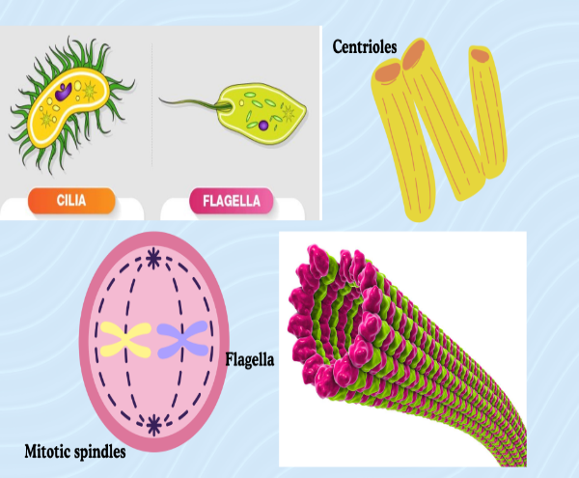Two types of tubulin are found alpha tubulin and beta tubulin

**Intermediate Filaments**

Intermediate filaments are composed of a family of related proteins that share common structural and sequence features.

* They have great tensile Strength
* Diameter is about 10nm.
* Made up of fibrous intermediate proteins
* Also involve in cell division and transport
* Composed of two anti parallel dimer

**IF PROTEIN CLASSES**

The Classification of intermediate filaments into diferent classes is based on the type of proteins that make up these filaments, the cell types in which they are found.

* Class I and II: Keratins (Acidic & Basic) - Epithelial Cells
* Class III: Vimentin - Mesenchymal Cells

Desmin - Muscle Cells

* Class IV: Neurofilaments - Nerve Cells
* Class V: Lamin - Nuclear Envelope

**Microfilaments**

Microfilaments also known as actin filaments, are the thinnest filaments and are responsible for cell movement and support

* The Major cytoskeletal protein of most cells is Actin
* 7nm in Diameter and up to several micrometers in length
* Supports the outer layer of the cell
* Responsible for movement

**STRUCTURES OF MICROFILAMENTS**

* G-actin is the monomeric form of actin and it binds ATP when it is in this Globular form.
* F-actin becomes ADP-bound because ATP hydrolysis is a natural consequence of actin polymerization.

**CYTOSKELETAL-RELATED DISEASES & DISORDERS**

* Muscular Dystrophy - a group of genetic disorders that affect muscle function and structure. It causes a progressive weakness and degradation of skeletal muscles.
* Progeria - aka Hutchinson-Gilford Syndrome is a rare genetic disorder that causes premature aging due to abnormalities in the nuclear lumina, a type of intermediate filament.
* Alzheimer’s & Parkinson’s Disease - in these diseases, there is an accumulation of abnormal proteins in the brain, which can disrupt the cytoskeleton and impair its function. This can lead to the degeneration of neurons and the loss of brain function.

**EXTRACELLULAR MATRIX AND CANCER**

**1, EXTRACELLULAR MATRIX**

**TISSUE**- It is a group of cells that have similar structure and that function together as a unit.

Extracellular matrix (ECM)- In the group of cells that composed the tissues, a complex support network called extracellular matrix, fills the spaces between them.

* A large network of proteins and other molecules that surround, support, and give structures to the cells and tissues in the body.

**Roles of Extracellular Matrix (ECM)**

* Scaffold formation and maintenance.
* Used in cell-to-cell communication.
* Changes cell behavior in response to environments.

Three Common Components of ECM

1. Proteoglycan network- Comprises of sugars called glycosaminoglycans.

* They exist as compressive filler substance to protect cells as well as storing many cellular growth and immune activating factors.

1. Fibrous proteins- Embedded within the proteoglycan network to form the basis of the structural scaffold.

* They also help attached the ECM to other nearby cells.

Common Constituents of Fibrous Proteins

1. Collagen- A strong tripled coiled helix protein comprised of two identical chains and another that varies slightly.

* They are interwoven within the ECM to form a basket weave.

1. Fibronectin- Come together to form insoluble fibers between cells.

* They bind collagen and integrity on the surface of local cells to allow cell-to-cell communication.

1. Integrins- A cell receptor that binds to microfilaments to convey messages to the cell to change behavior and respond to environments.

* They also helps cells stick together in the ECM.
* Hence, together during contractions and movements of the ECM, the integrins rearrange the internal microfilaments, which send signals to the nucleus to turn on and off certain genes that allow cells to adapt to the behavior of the changing environment.

**FIBROBLASTS**

* Most common type of stromal cell.
* They secrete specific products defining the specific characteristics of the ECM to best fulfill their role in the tissue.

**2. TUMOR**

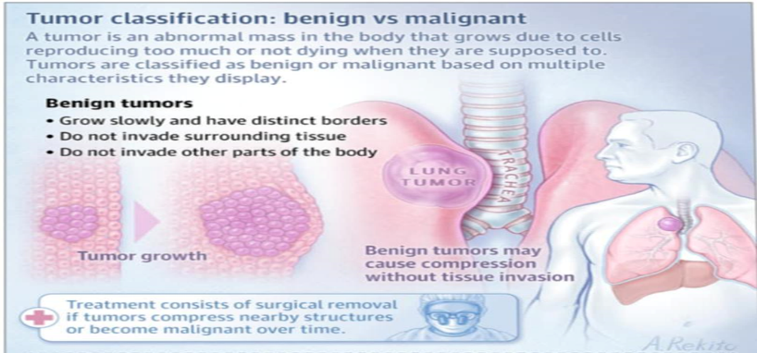

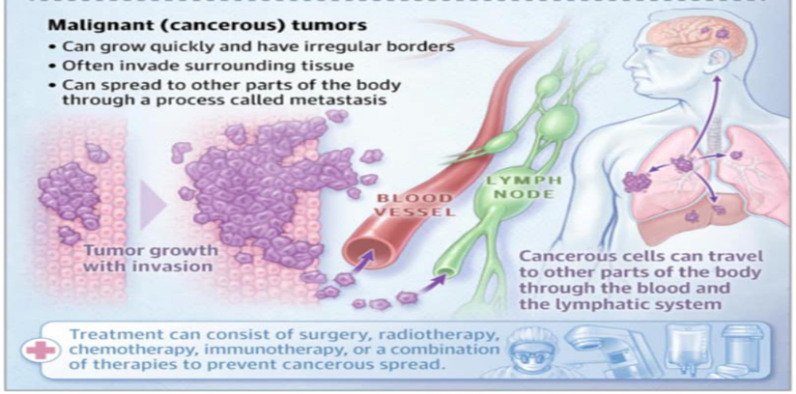

**Tumor Microenvironment**

- is a highly heterogeneous environment around a tumor, that includes cellular components (fibroblasts, endothelial cells, adipocytes, immune and inflammatory cells) and a non-cellular component termed the extracellular matrix (ECM).

**RELATIONSHIP BETWEEN ECM   
AND CANCER CELLS**

- During cancer progression, carcinoma cells recruit host stromal cells, which change their properties and metabolism.

**Cancer-associated fibroblasts (CAFs)**

- are normal tissue components that have been subverted by cancer cells to produce factors that promote cancer growth, angiogenesis, and invasion including specific collagen types, growth factors, enzymes, and other soluble factors that significantly alter the ECM.

**MECHANISM OF CELLULAR COMMUNICATION (LACK)**

**EPIDERMIS…. (LACK)**